# **CTF Topic: CVE**



# **1. Introduction**

A CVE (Common Vulnerabilities and Exposures) number is a unique identifier assigned to a specific computer vulnerability. It is a standardized way to identify and reference publicly known information security vulnerabilities. A CVE number is a string of characters that starts with “CVE-” followed by a unique identifier, such as “CVE-1999-0067”.

# **2. Tools and requirements**

JSON mitre

# **3. Scenario**

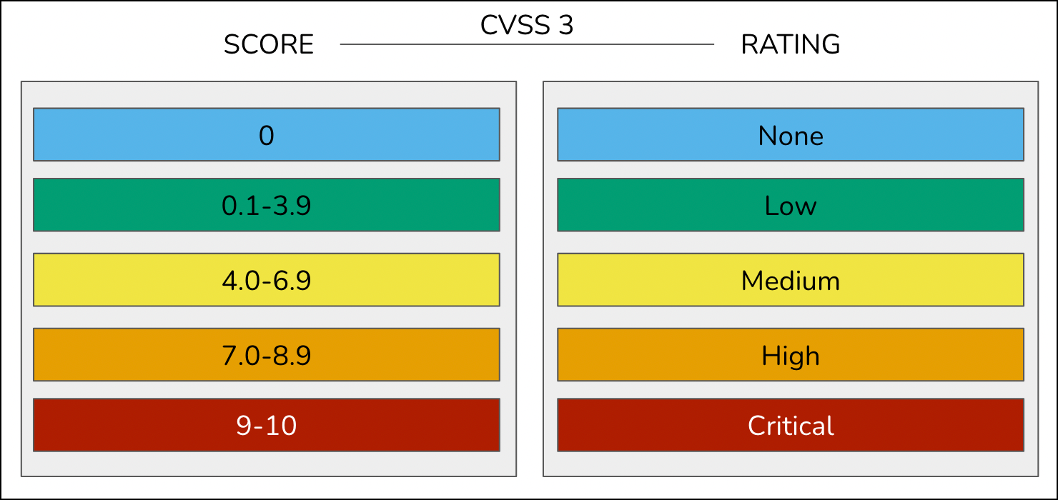

A new vulnerability was released and given a new name according to CVSS score. The pentester said that its impact is high and obtained a CVSS score 8.5. The CVE number assigned was CVE-2021-26855.

# **4. Process to follow while performing CTF**

To perform this process go to the link given below and search the CVE number CVE-2021-26855.

<https://www.cve.org/Media/News/item/blog/2022/10/06/CVE-Records-Are-Now-Displayed>

**Let's Begin The Challenge**

# **Question**

**Flag 1: What is the Vulnerability name?**

**Answer: Microsoft Exchange Server Remote Code Execution Vulnerability**

**Flag Captured.**

**Flag 2: When was the vulnerability released?**

**Answer: 2021**

**Flag Captured.**

# **Hint**

